

|  |  |  |  |  |  |  |  |  |
| --- | --- | --- | --- | --- | --- | --- | --- | --- |
|  | | | | | | | | |
|  | | UEECS0003 & UEECS0022 | | | | |  | |
|  |  | | | | | | |  |
|  | | | |  |  | | | |
|  | | | | PRACTICAL ASSESSMENT #3: STUDENT NAME: Richard Pountney  STUDENT ID: 30007736 |  | | | |
|  | | | |  |  | | | |
|  | | |  | | |  | | |

# PART A: ASSEMBLE DESKTOP PC

All the parts

### 

Disc Drive in mount.

Heat Sink

USB & AUX ports

CPU Chip

Closer look at some of the parts

### 

SATA Cables

Hard Drive

RAM Sticks

CPU Chip

Heat Sink

USB & AUX ports

Closer look at some parts

### 

Power Unit

The Computer tower with Motherboard in & Power unit in.

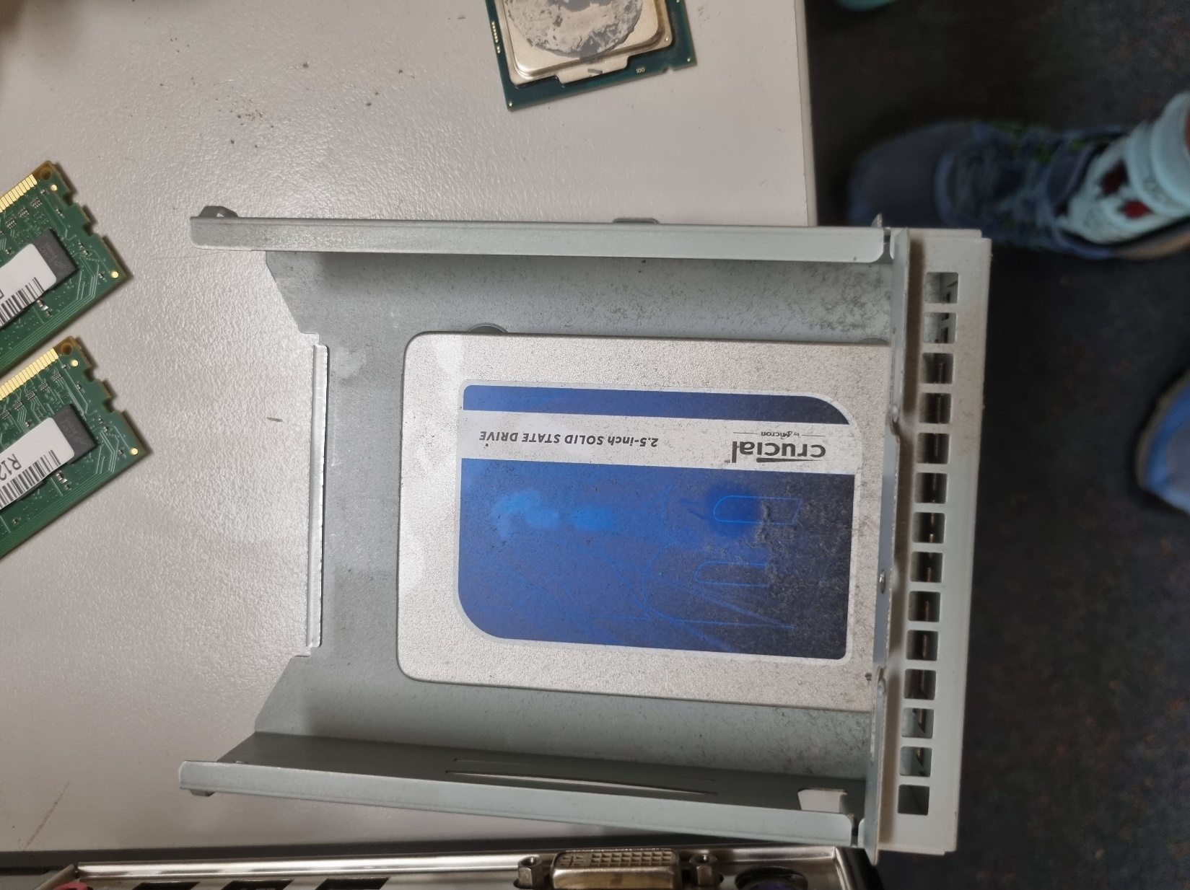

Close-up of hard drive

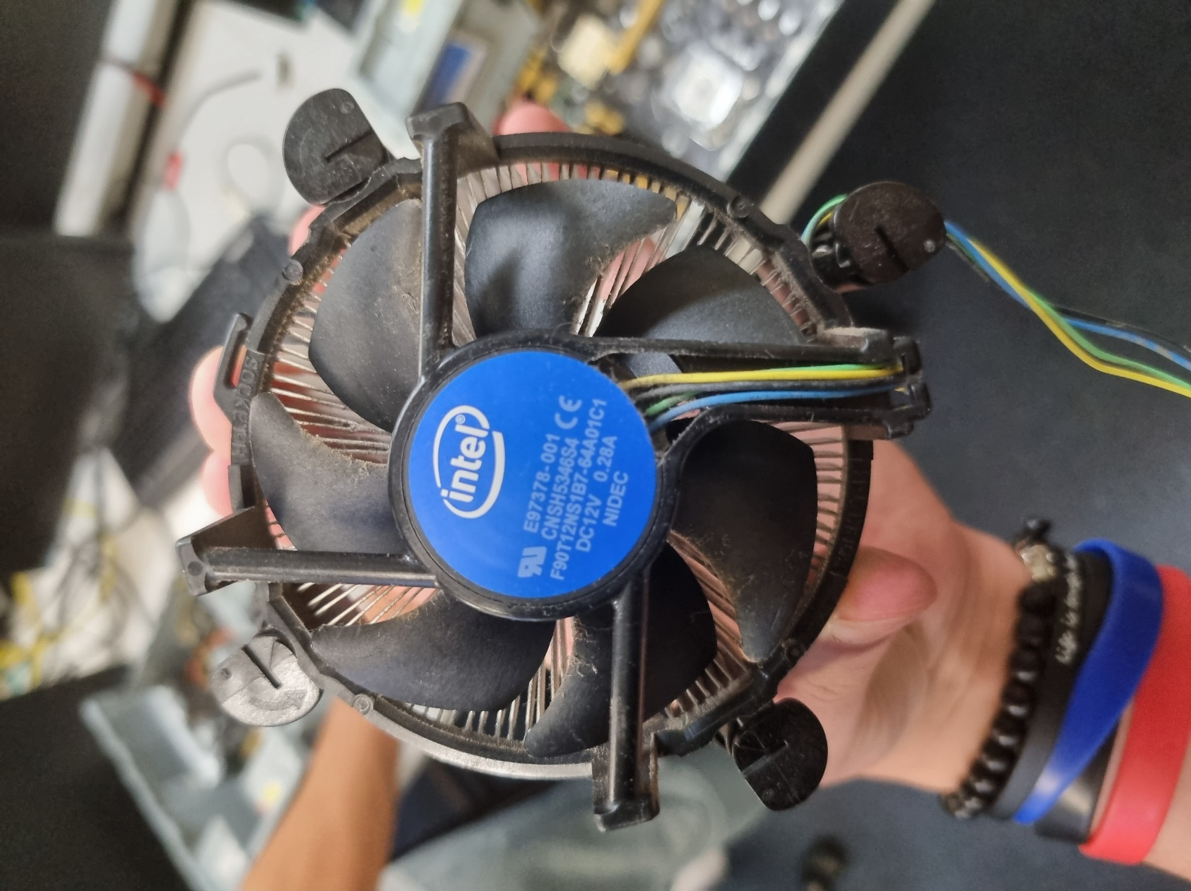

Close-up of Heat Sink

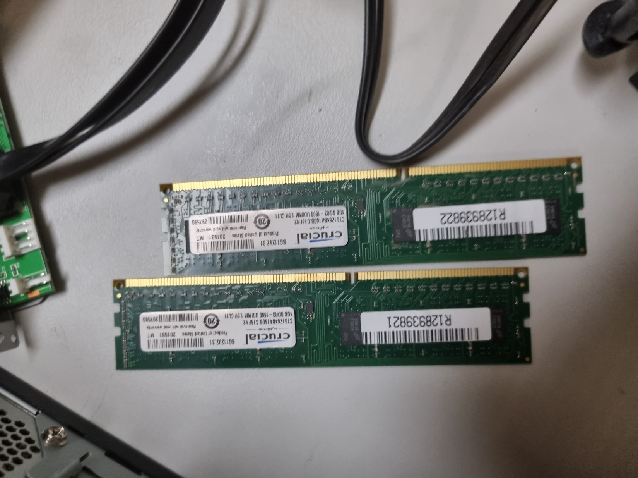

Close-up of RAM sticks

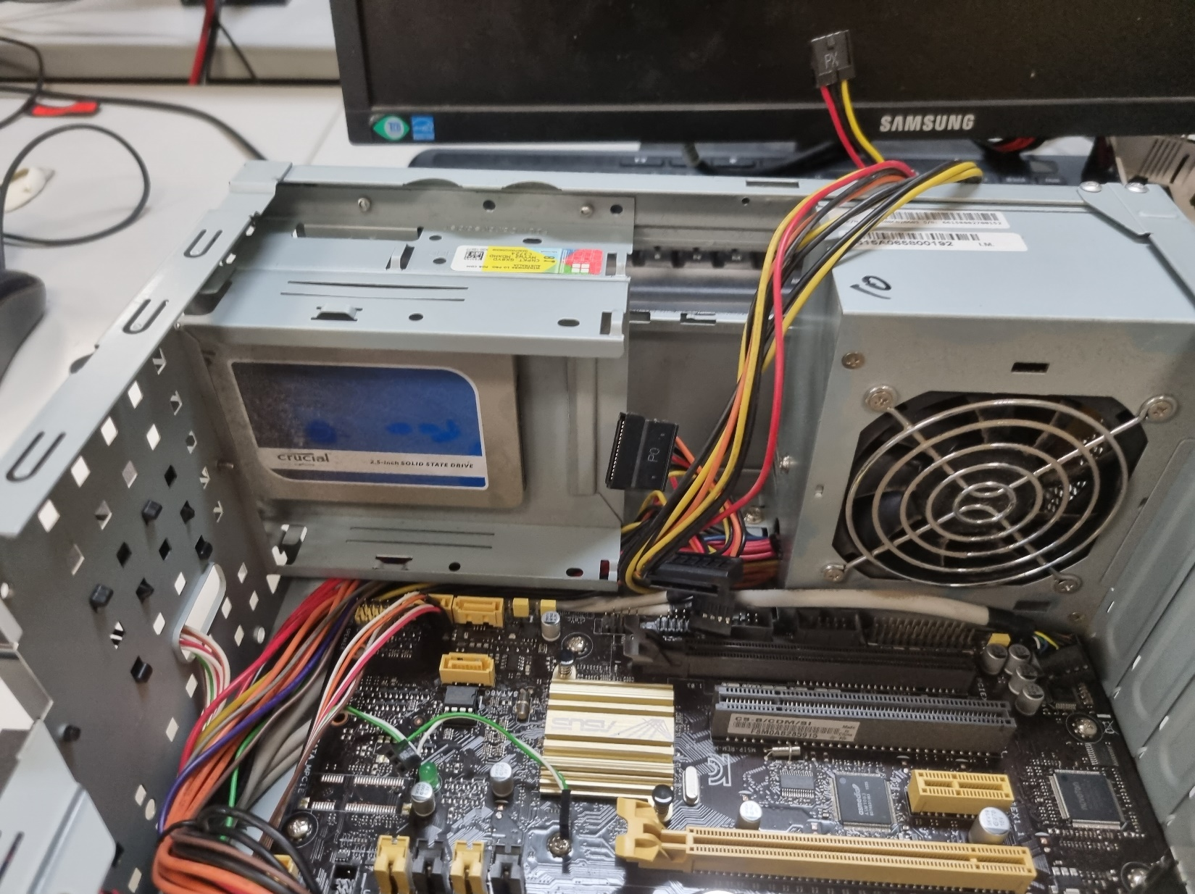

Put the Hard Drive on its mounting unit & slot it in from the front face of the tower.

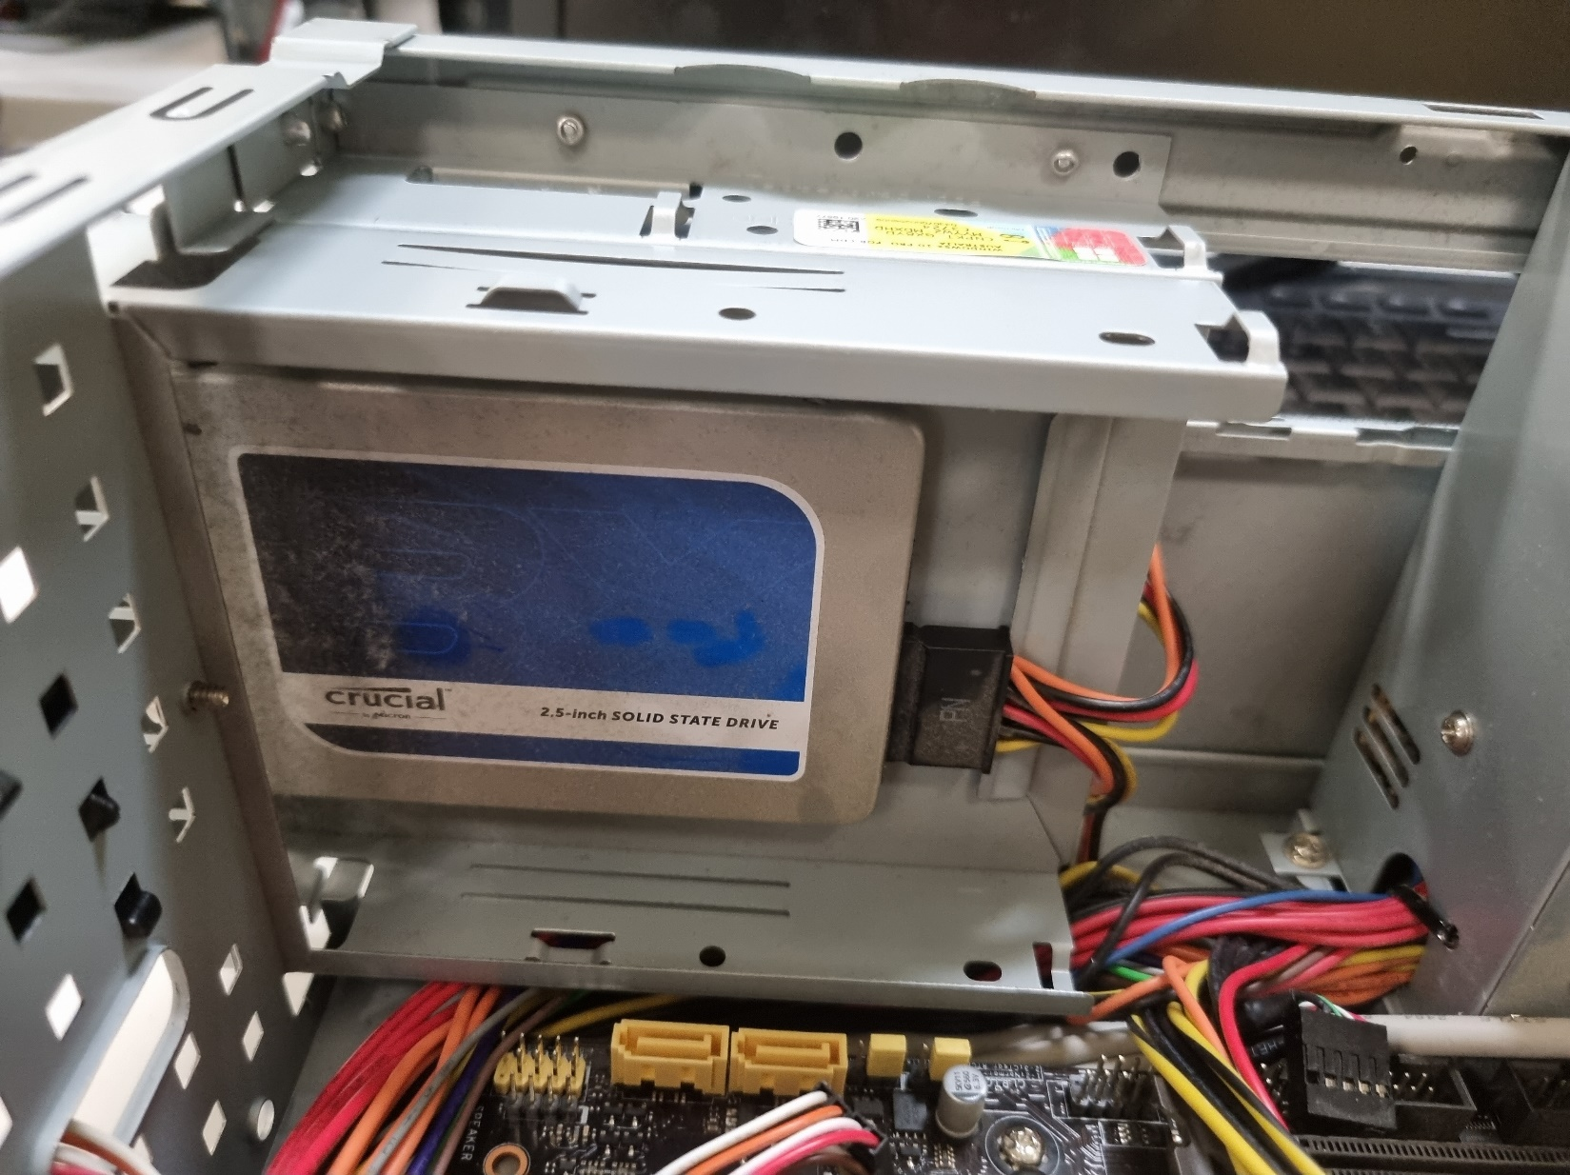

Plugged in the power cable to the hard drive.

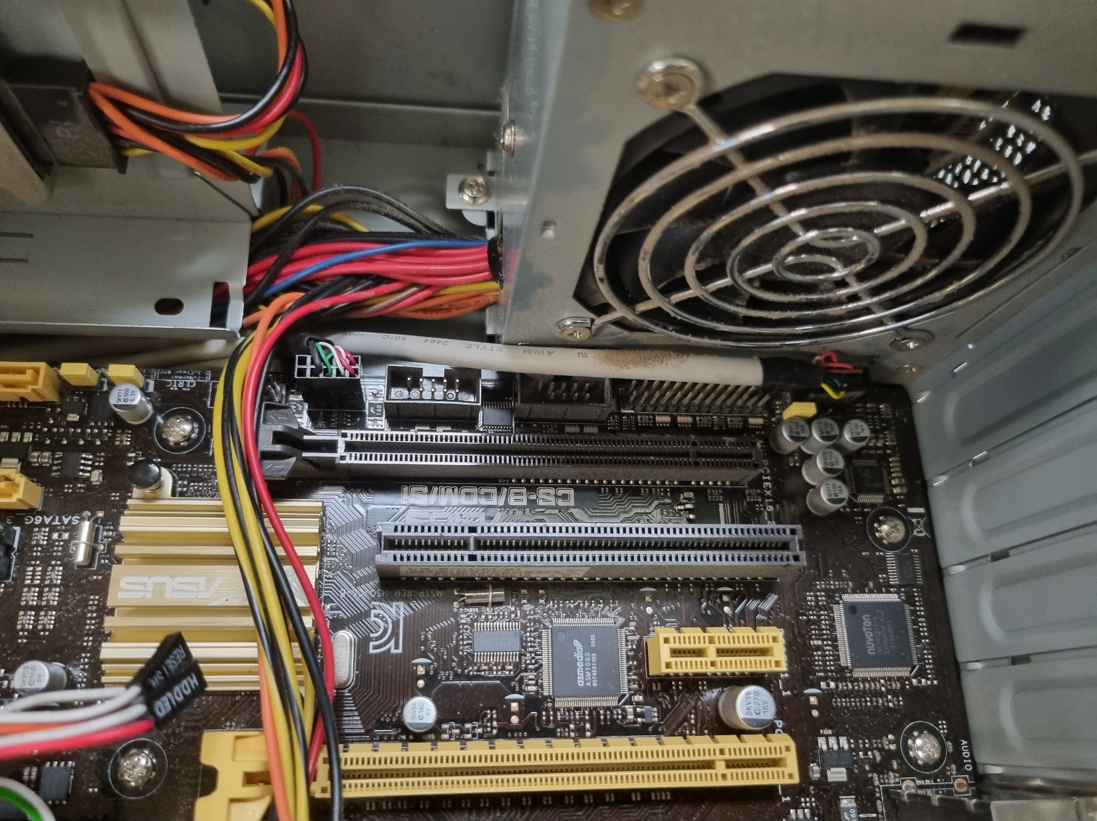

Plugged this cable in

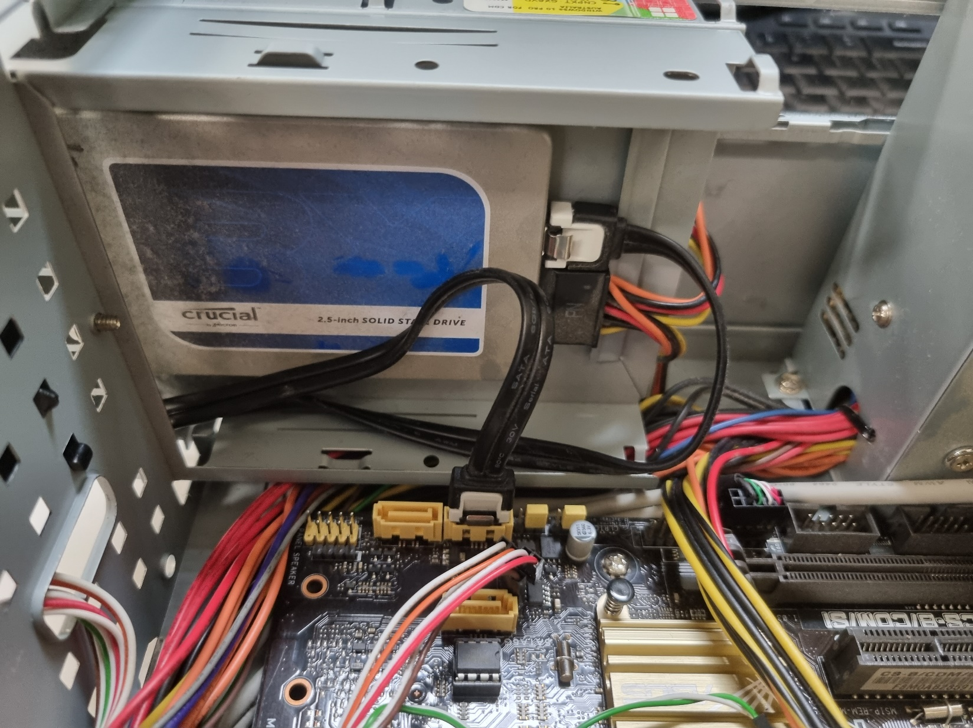

Plugged a SATA cable into the hard drive & the motherboard

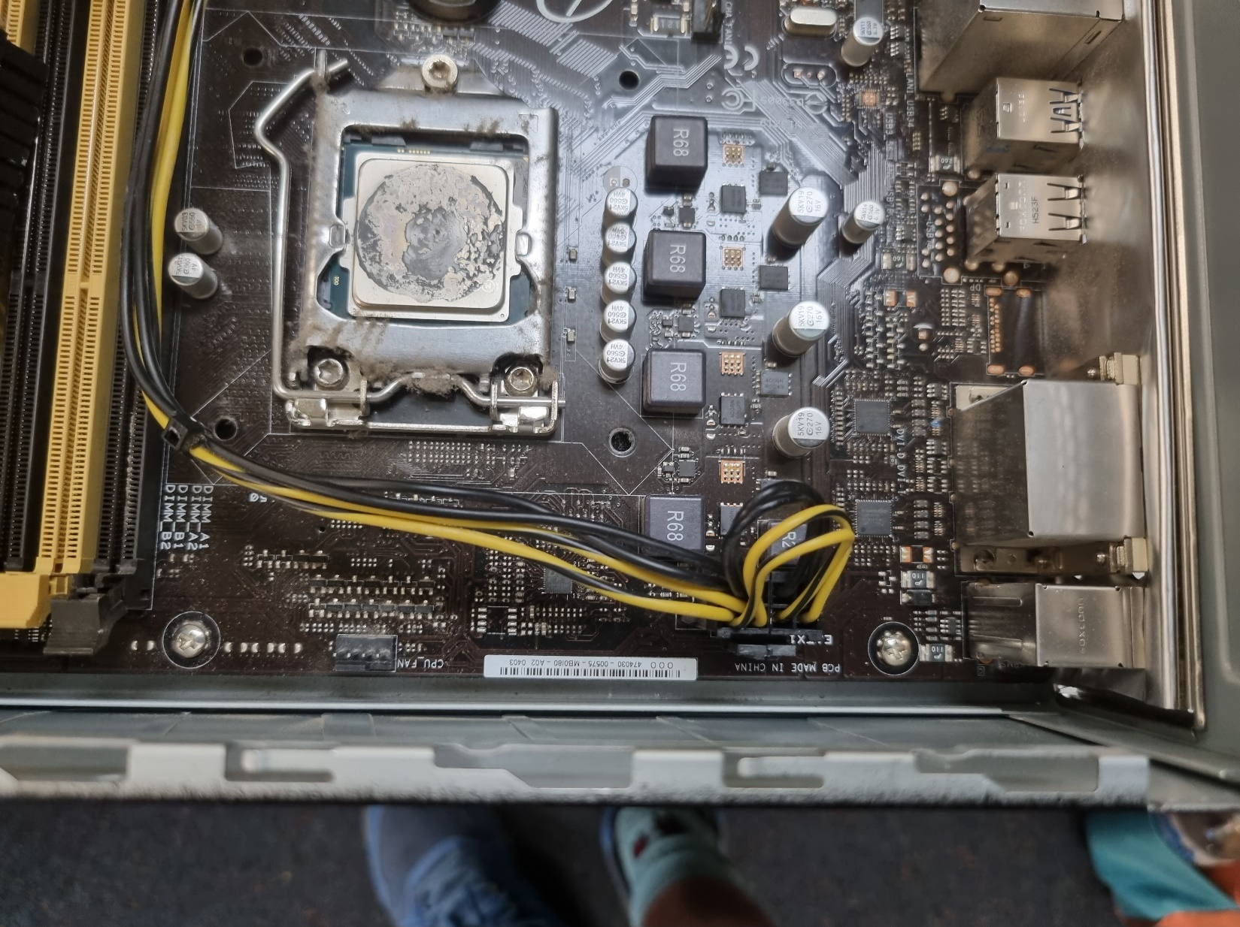

Inserted the CPU

Plugged in this Cable

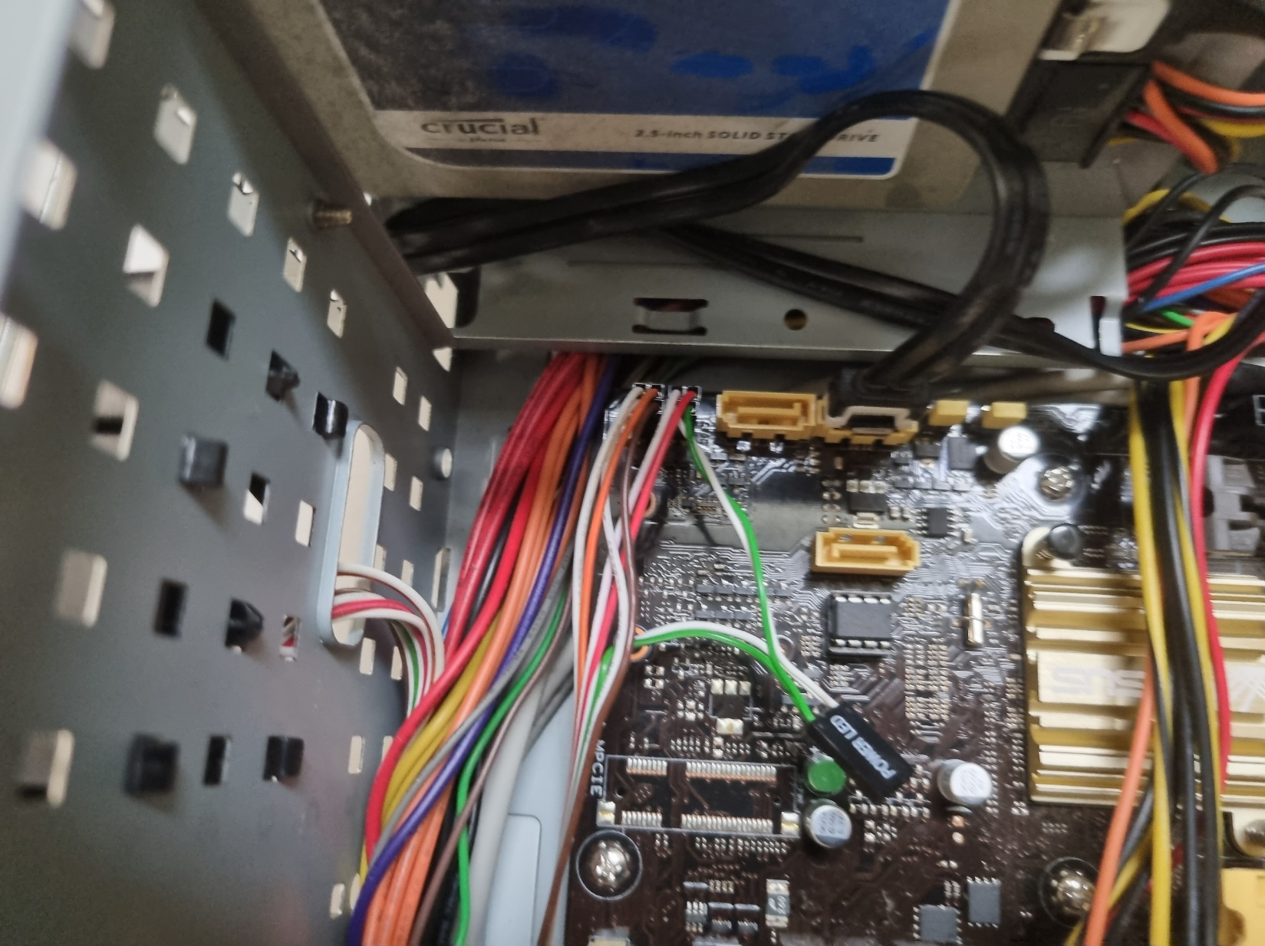

Plugged in front lights & connections.

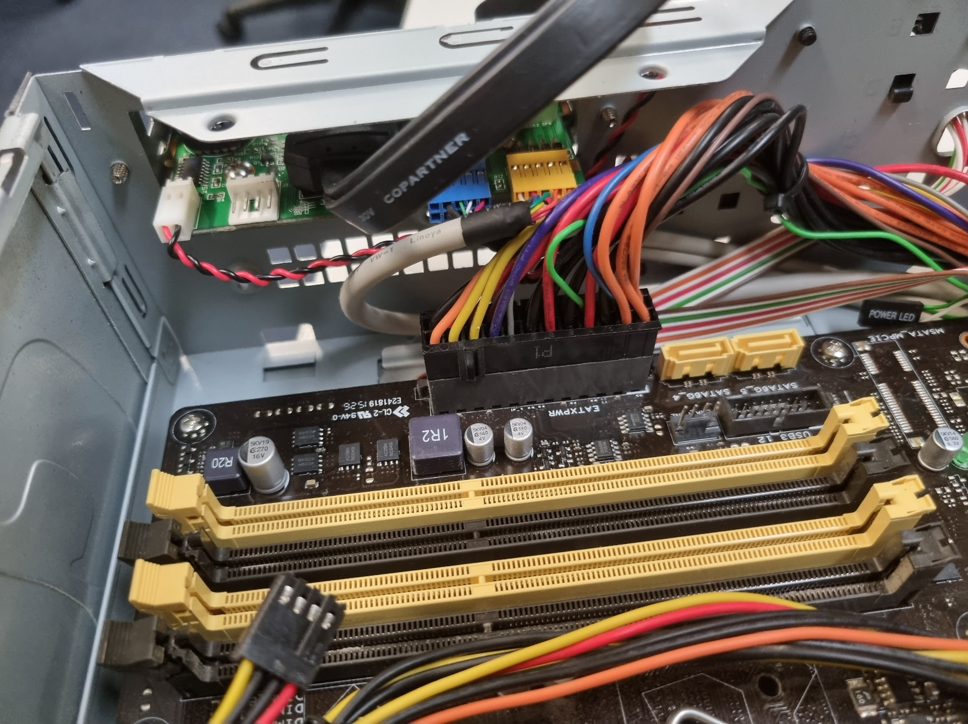

Plugged in these cables

Plugged in this

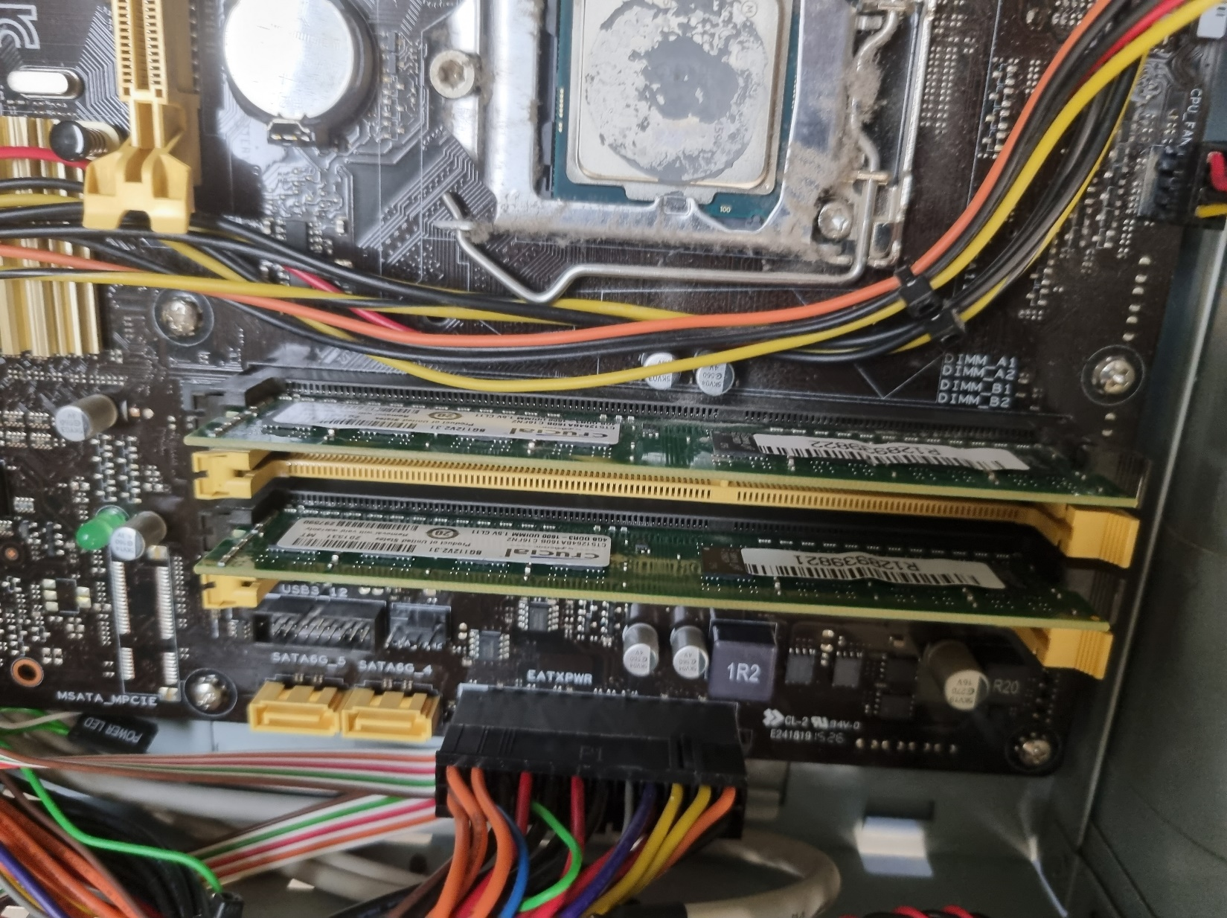

Plugged in the RAM sticks

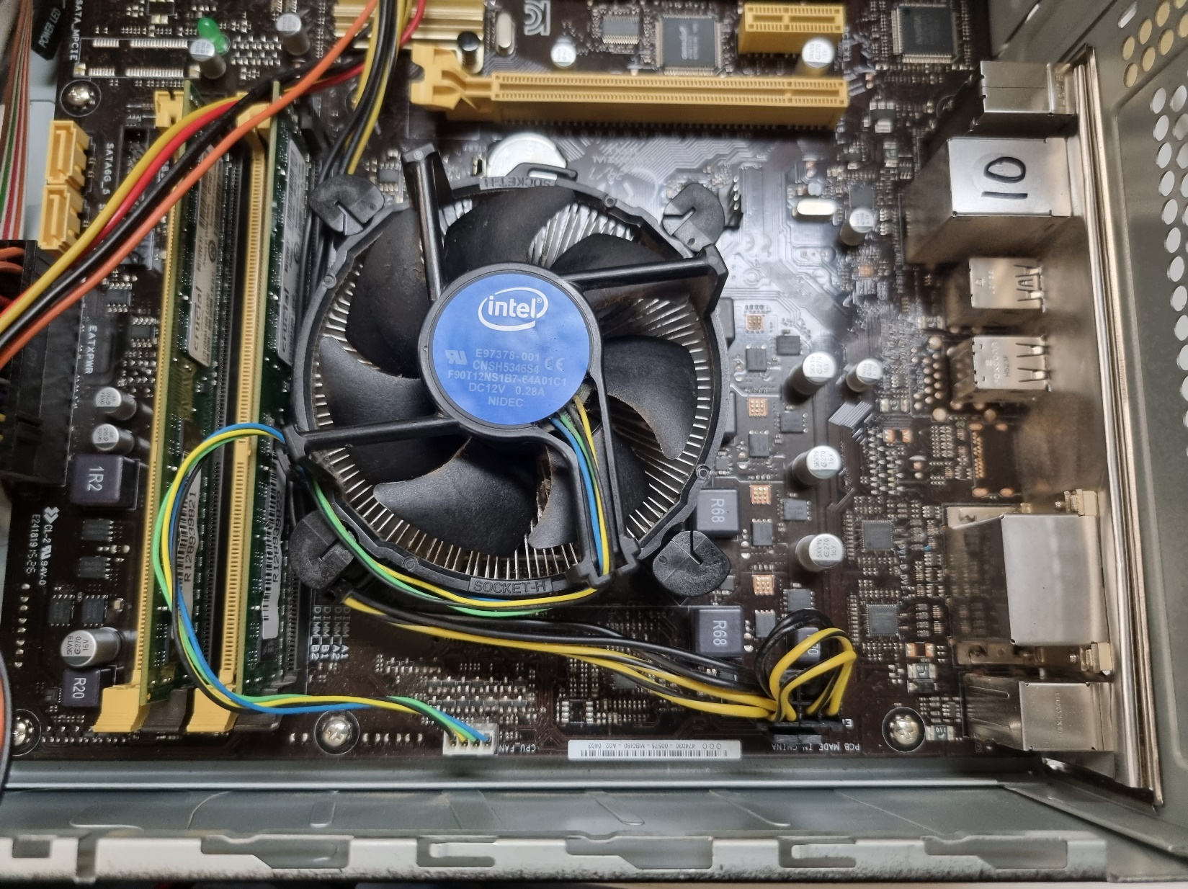

Attached the Heat Sink & Plugged in its fan.

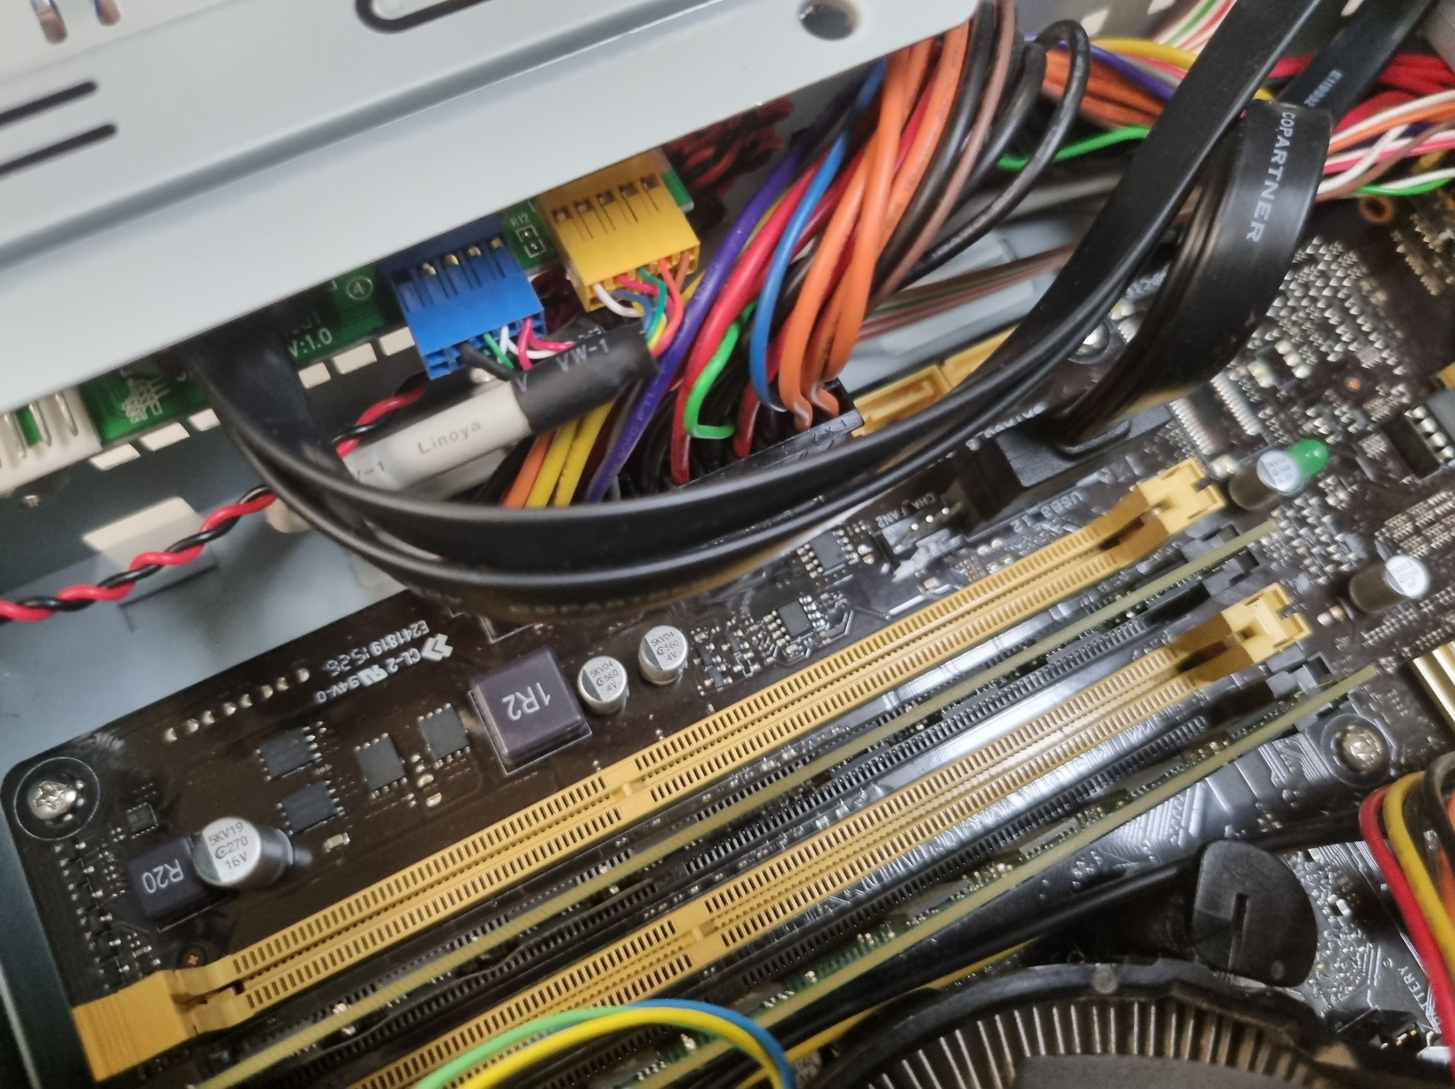

Plugged in this USB connection Cable

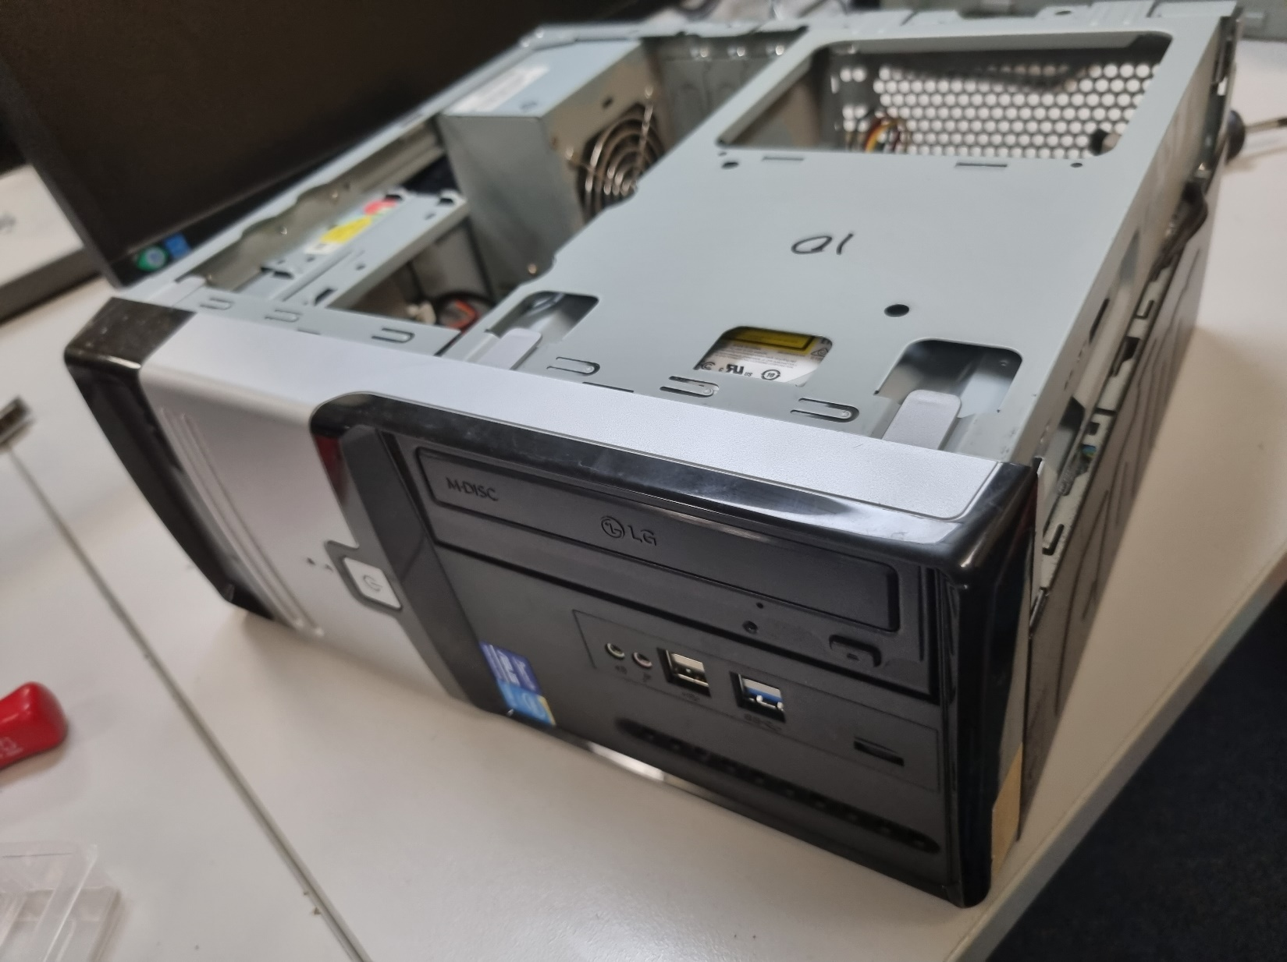

Put the disc reader & mount it on & attached the front panel.

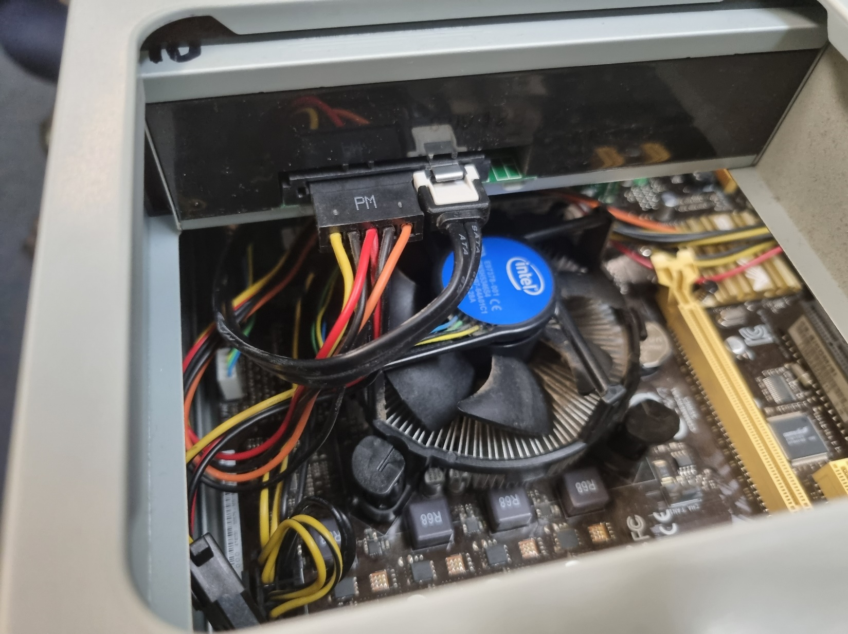

Plugged the power into the disc reading & plugged in the Second SATA cable as well.

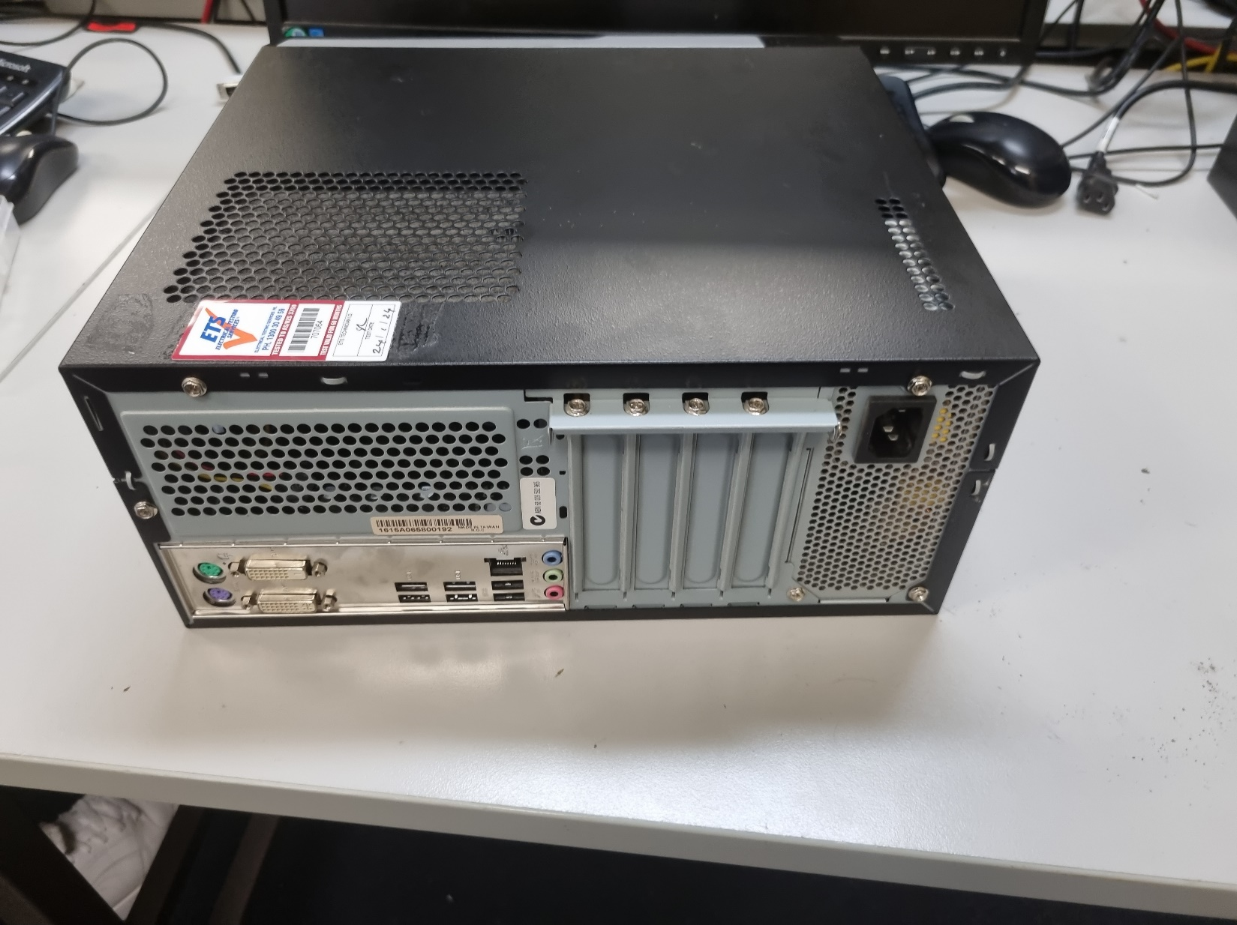

Mounted side panel on.

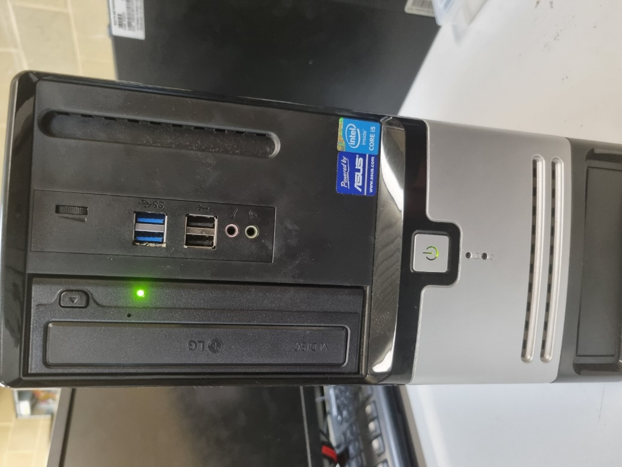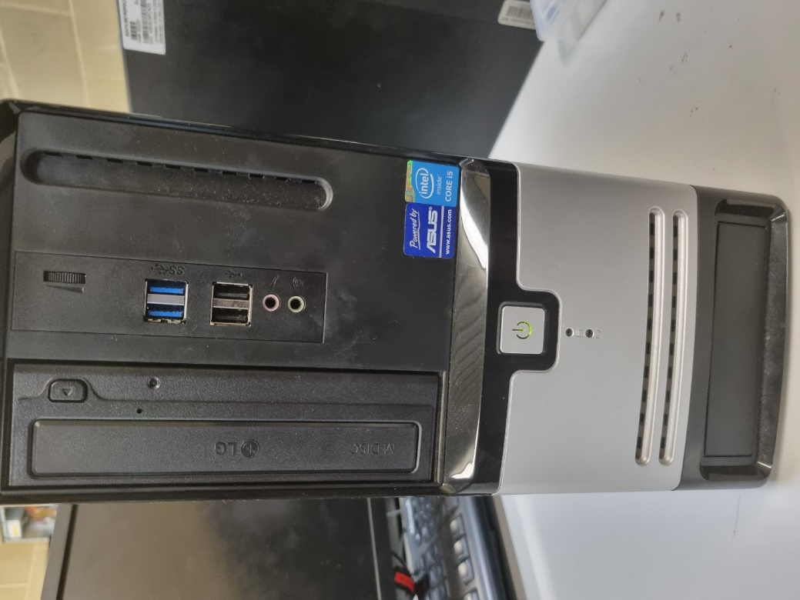

Powered it up & it works correctly.

# PART B: BASIC PC TROUBLESHOOTING

### **Issue 1: "customer: I can connect to my WiFi network, but I can't access any websites."**

|  |  |  |
| --- | --- | --- |
| Causes | Solutions | Category (Hardware / Software) |
| The modem isn’t plugged in properly | Make sure the ethernet cables & phone line are plugged in properly. | Hardware |
| Router hasn’t been turned of in quite a while | Restart/Reboot your router | Hardware |
|  |  |  |

### **Issue 2**: **Customer Report: "My keyboard and mouse stop working randomly, and I have to restart my PC to get them working again."**

|  |  |  |
| --- | --- | --- |
| Causes | Solutions | Category (Hardware / Software) |
| The software for the devices isn’t installed | Install the correct drivers | Software |
|  |  | Hardware |
|  |  |  |

**Issue 3: Customer Report: "My computer says, 'Disk Boot Failure' when I try to start it."**

|  |  |  |
| --- | --- | --- |
| Causes | Solutions | Category (Hardware / Software) |
| The boot disk has been corrupted | Install new OS on the boot disk | Software |
| Boot disk missing | Find the boot disk or install a new one | Hardware |
|  |  |  |

### **Issue 4: Customer Report: "My laptop gets super-hot after just a half-hour of use and then shuts down unexpectedly."**

|  |  |  |
| --- | --- | --- |
| Causes | Solutions | Category (Hardware / Software) |
| The cooling is blocked so the CPU can’t get cooled down | Clean the inside of the computer | Hardware |
|  |  |  |
|  |  |  |

### **Issue 5: Customer Report: "When I boot up my computer, the screen displays weird colors or sometimes just goes black."**

|  |  |  |
| --- | --- | --- |
| Causes | Solutions | Category (Hardware / Software) |
| Graphics Card not connected properly |  | Hardware |
| Display Setting had been messed with |  | Software |
| Broken |  |  |

### **Issue 6: Customer Report: "I tried to upgrade my RAM, but now my computer won't boot and beeps continuously."**

|  |  |  |
| --- | --- | --- |
| Causes | Solutions | Category (Hardware / Software) |
|  |  | Hardware |
|  |  |  |
|  |  |  |

### **Issue 7: Customer Report: "I tried to update to the latest version of the operating system, but now it's stuck in a loop and won't start up."**

|  |  |  |
| --- | --- | --- |
| Causes | Solutions | Category (Hardware / Software) |
|  |  | Software |
|  |  |  |
|  |  |  |

### **Issue 8: Customer Report: "There's a loud grinding noise coming from my computer tower."**

|  |  |  |
| --- | --- | --- |
| Causes | Solutions | Category (Hardware / Software) |
| Things are up against the fan blades |  | Hardware |
|  |  |  |
|  |  |  |

# PART C: INSTALL AND TEST OPERATING SYSTEM

# PART D: SETUP BASIC PC NETWORK

|  |  |  |  |  |
| --- | --- | --- | --- | --- |
| PC | LAN | IP address | Subnet | Default Gateway |
| PC0 | LAN1 | 192.168.1.100 | 255.255.255.0 | 192.168.1.1 |
| PC1 | LAN1 | 192.168.1.101 | 255.255.255.0 | 192.168.1.1 |
| PC2 | LAN2 | 192.168.2.100 | 255.255.255.0 | 192.168.2.1 |
| PC3 | LAN2 | 192.168.2.101 | 255.255.255.0 | 192.168.2.1 |